**Digital Input/Output**

Step 1: Create a MPLAB Project and Open MHC (Refer to Creating First project).

Step 2: Clock Configuration:

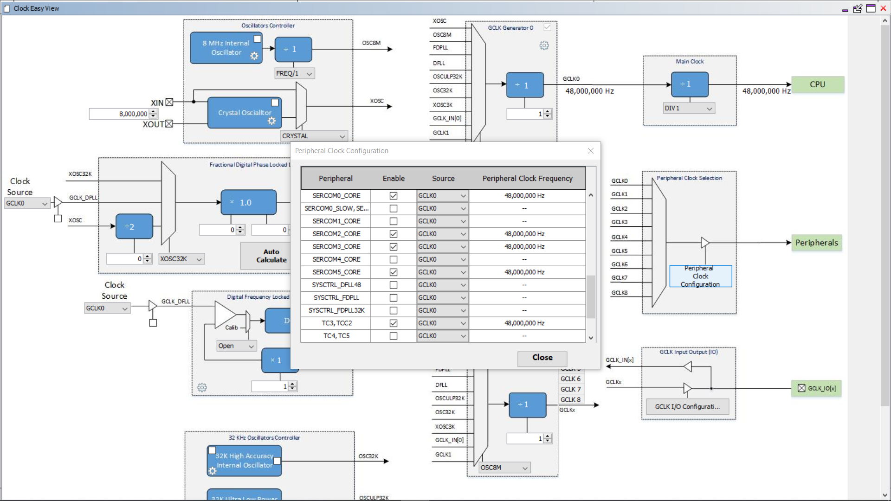

Step 3: Set PB10 as GPIO output. Change Custom name as you want.

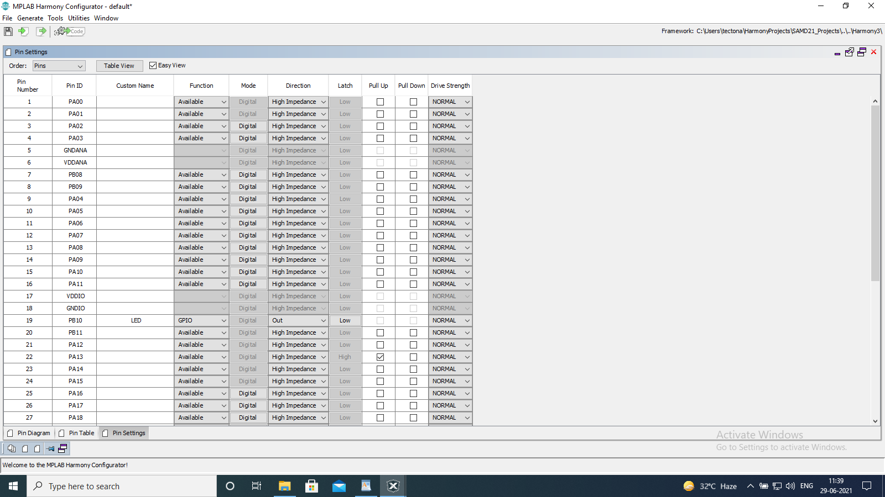

Step 4: Close and go back to Harmony Configurator

Step 5: Click on Generate Code.

Step 6: Go to projects in MPLAB IDE, you can see the generated header and source files.

Step 7: Go to header files->config->default->peripheral->port->plib_port.h

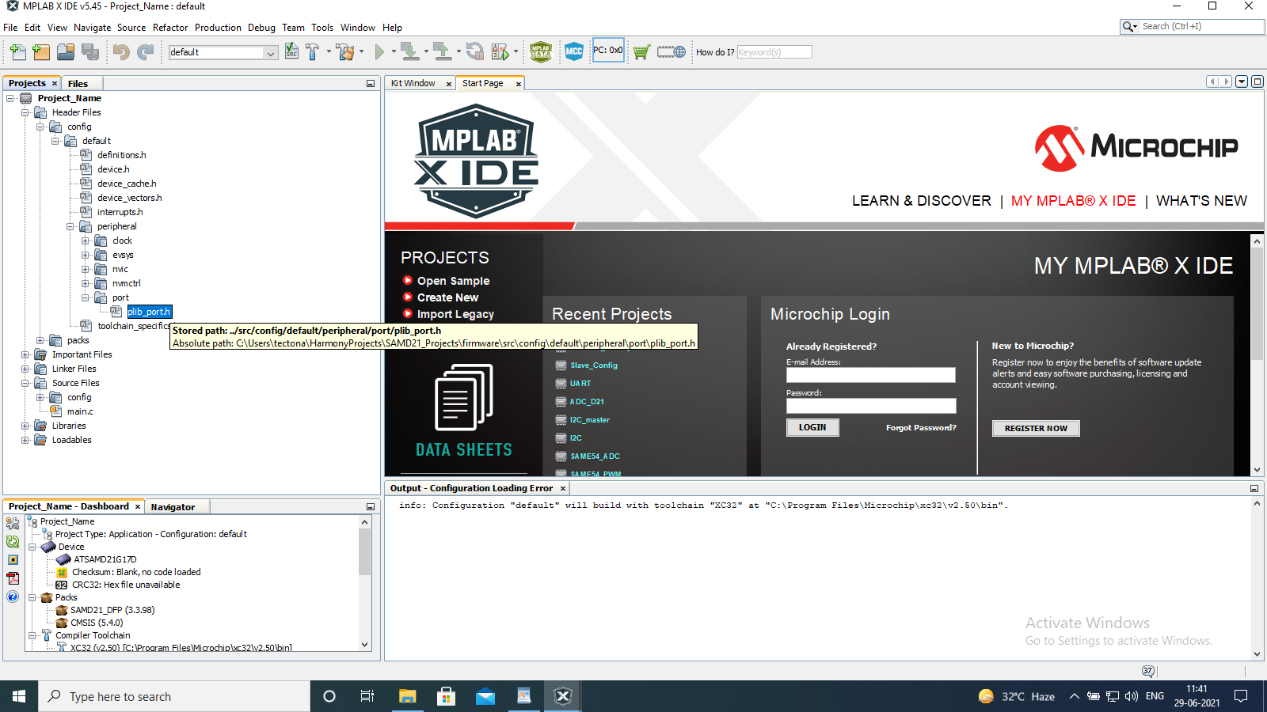

Step 8: In plib_port.h file copy LED_Toggle() function and paste it into main().

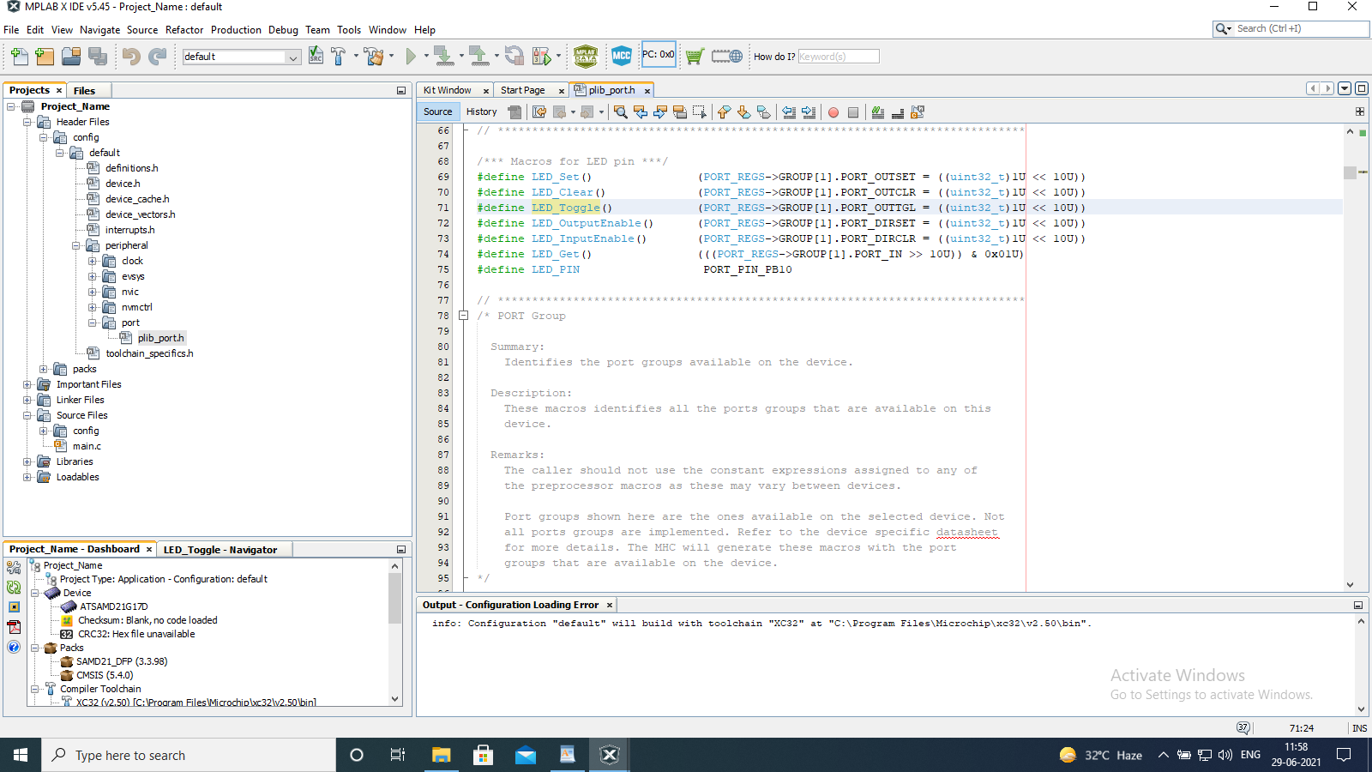

Step 9: Build the project and dump it into the hardware.

Code:

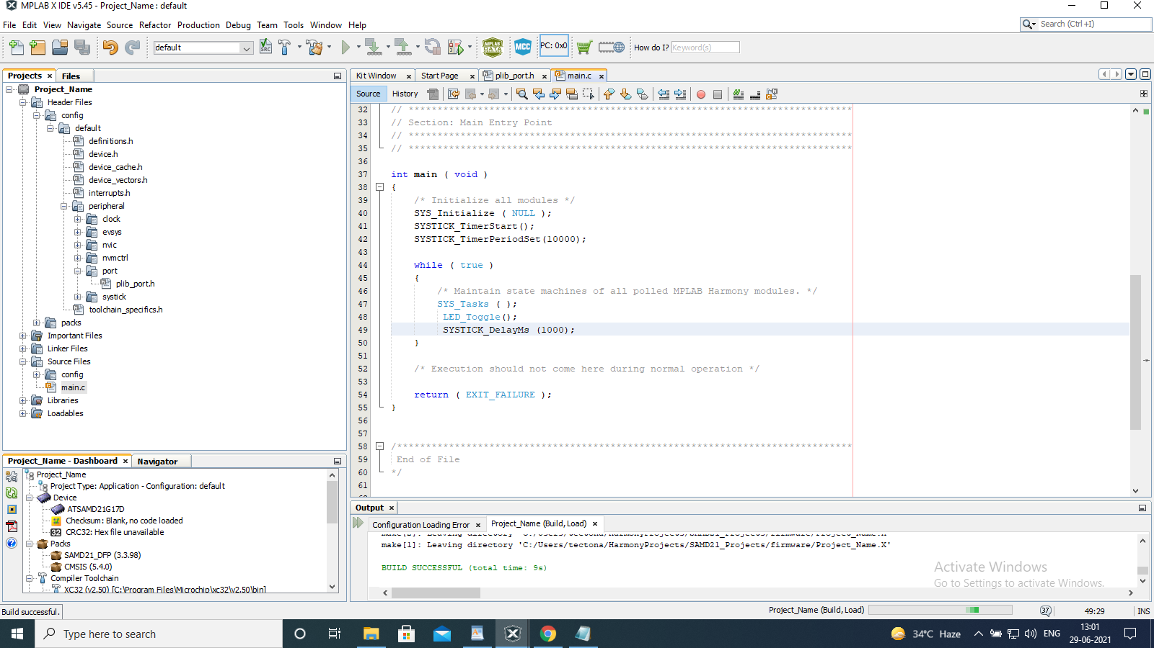

PB10 is the on board LED. The LED will toggle every 1 second.